Building Supervisor Procedures

- Receive a link from Space Management to join a Microsoft Teams Group called “WVU Space Audit”

- Open Microsoft teams and select the “team” tab > then click on the file “WVU Space Audit” > Open the instructions and space audit excel file > Read the instructions first then open the space audit file .

- Don’t download your own copy of the file and send to us in an email. Input your data only into the space audit excel spreadsheet provided in the teams group file.

- Open the respective file named after the building supervisor.

- The Room data can be reviewed and updated in Teams or Excel but the file should not be saved to your hard drive to make your edits.
  - To edit in Teams, you will remain working in Teams to complete your review.
  - To edit in Excel, you will select Editing in the upper right of the file in Teams, select Open in Excel, and the file will open in Excel for you to complete your review.
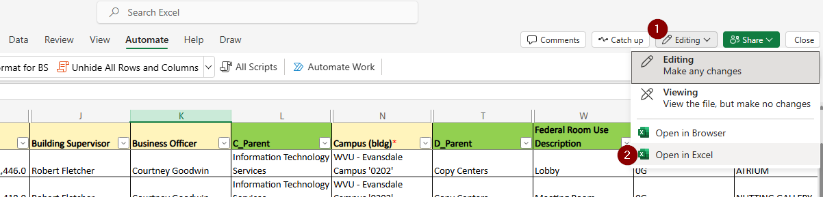

When your review has been completed in Excel, you can close the file.

- If necessary, you can filter the file to the data you would like to review. If prompted, you will want to view your filters only.

- When reviewing the file:
  - Columns in Green contain the information that needs to be reviewed and updated. If no update is needed and data is correct, you don’t need to input anything except for the Business officer(s) initials after their review.
  - Columns in Yellow is the data associated with the room to assist with your review and are not available to be edited.
  - Column labeled “Comments” is any comments that you would like to make associated with that room. Anything that is added to this field will not be added to the Room record.
  - Column labeled “Approval” will be used for the Business Officer initials when their review of that line is completed. The Business Officer is required to initial all lines in this column after reviewing document.

- Building Supervisors when your updates and reviews are completed (including Business Officer(s) review and initialing), close the file and let the Space Management Team know you are done by sending an email to Matthew.Latimer@mail.wvu.edu and CC lknicele@wvu.edu
Example:
Space Management, I John Doe (Building Supervisor) have completed my space audit for the current year. I also had the respective spaces business officer Jane Smith review / approve my updates.

Things to keep in mind:

- Although you will have access to other Building Supervisors files, you should only be reviewing and updating the Room data for your applicable Building(s).

- All changes made to the files are tracked by user.

- Building Supervisors can allow other WVU Employees to have access to the Teams site by requesting that access through the Space Management Team. Please note the Building Supervisor is ultimately responsible for the completion and accuracy of the space audit. If you are allowing someone to access your file and we give them permission, please review what they have done before completing and notifying us.

- All updates to the Room data must be completed in the Teams version of the file the Space Management Team has saved on the Space Audit Team. No other version of the file will be accepted.

- If you chose to edit the file in Excel, you should not save the file to your hard drive to make your edits.

If you chose to save the files to your hard drive, you will be expected to re-add your updates to the files the Space Management Team have saved in Teams.

- If someone else is reviewing the file at the same time as you, the field they are currently in will be blue with their initials in the upper right corner.

You can hover over the initials to see the person’s full name.

Everyone working in the file at the same time, whether in Excel or Teams, will see updates in real time.
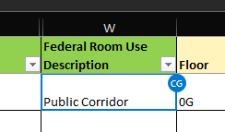

- Rows and columns should never be deleted, reordered, or added.

